OUR BIOLOGY PRACTICAL SCHEDULE (Jan to Oct)
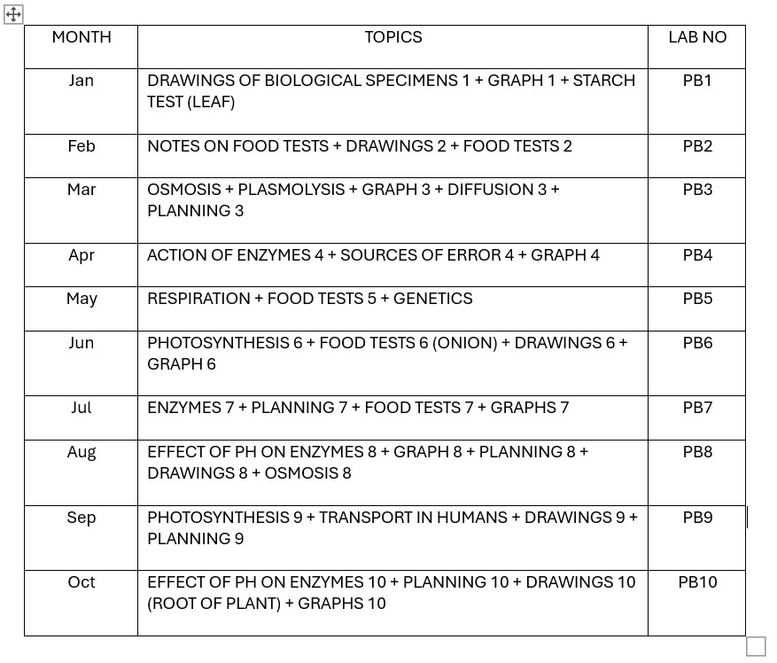
*Other labs, such as PB11-PB12, are also available for those who want further training or as mock exams.
OUR CHEMISTRY PRACTICAL SCHEDULE (Jan to Oct)
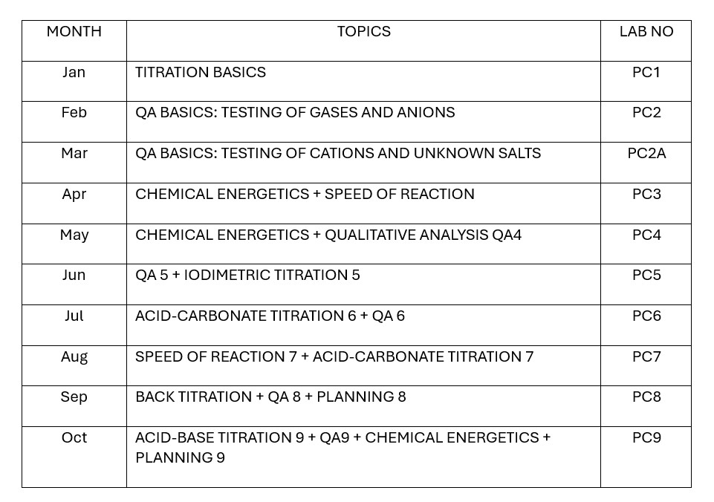
*Other labs, such as PC10 – PC16, are also available for those who want further training or as mock exams.
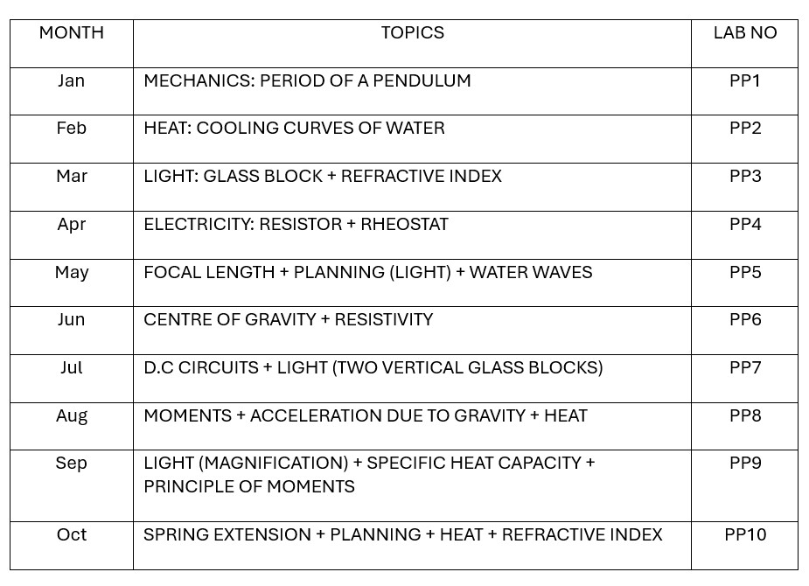
OUR SCIENCE (BIOLOGY) PRACTICAL SCHEDULE (Jan to Oct)
*Other labs, such as PB11-PB12, are also available for those who want further training or as mock exams.
OUR SCIENCE (CHEMISTRY) PRACTICAL SCHEDULE (Jan to Oct)
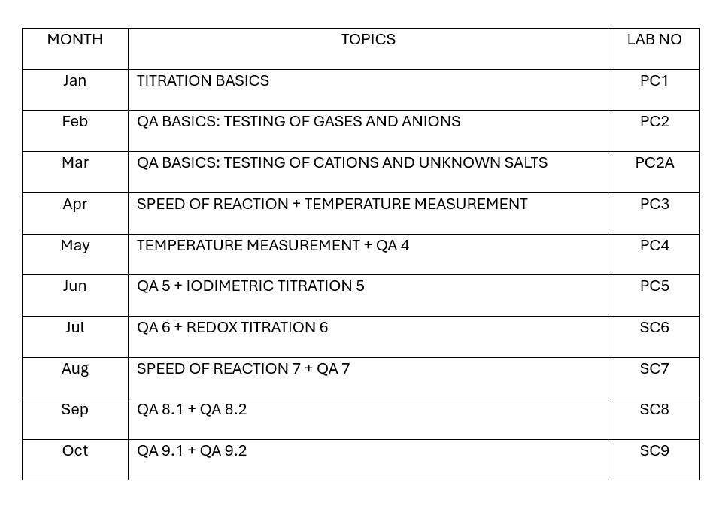
*Other labs, such as PC10 – PC16, are also available for those who want further training or as mock exams.
OUR SCIENCE (PHYSICS) PRACTICAL SCHEDULE (Jan to Oct)
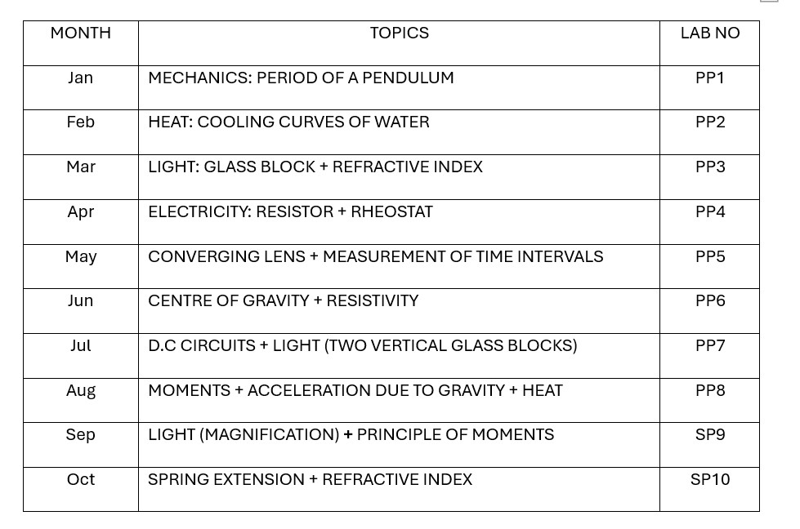
*Other labs, such as PP11-PP17, are also available for those who want further training or as mock exams.
OUR H2 BIOLOGY PRACTICAL SCHEDULE (Jan to Oct)
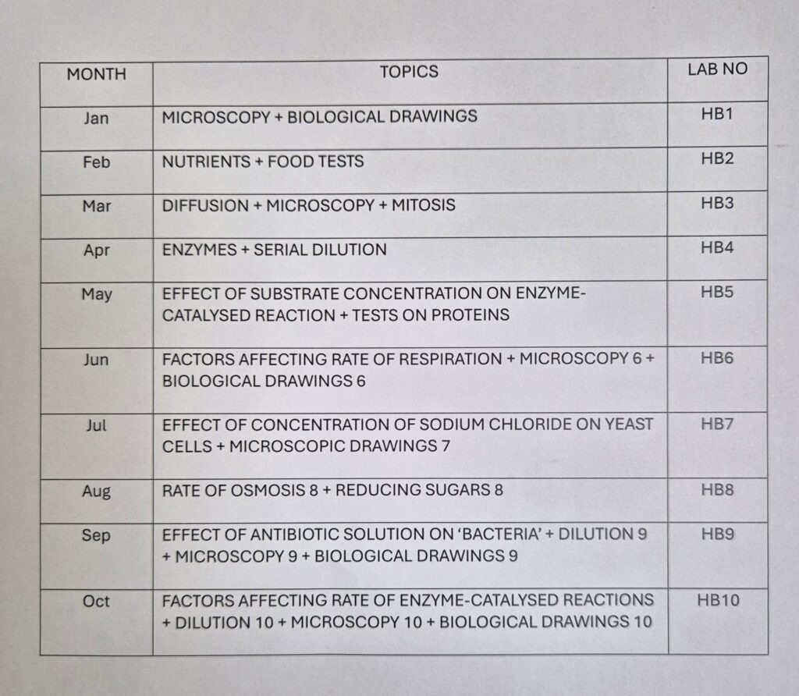
*Other labs, such as HB11, are also available for those who want further training or as mock exams.
OUR H2 CHEMISTRY PRACTICAL SCHEDULE (Jan to Oct)
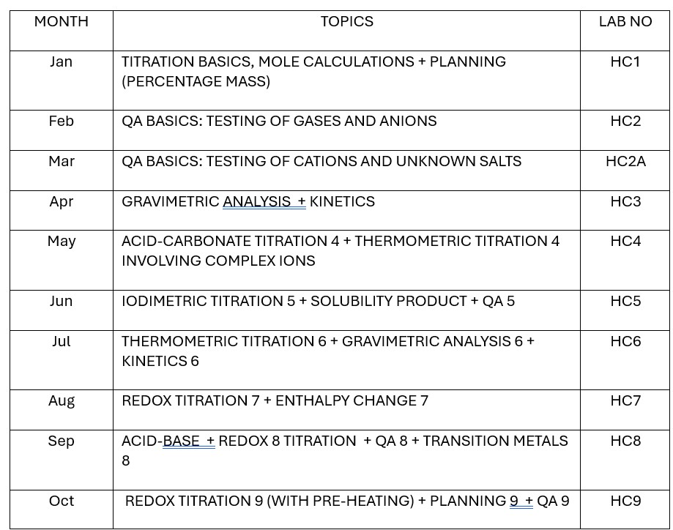
*Other labs, such as HC10-13, are also available for those who want further training or as mock exams.
OUR H2 PHYSICS PRACTICAL SCHEDULE (Jan to Oct)
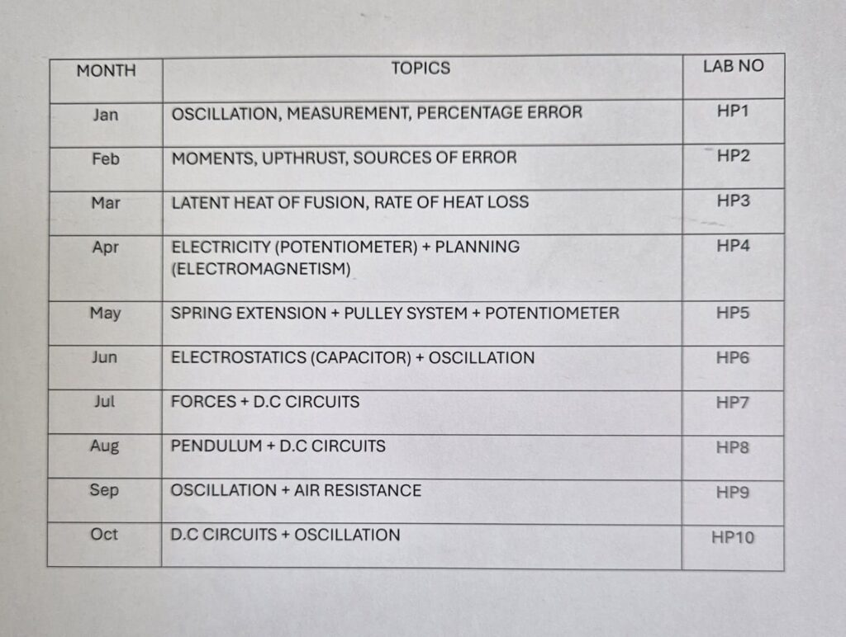
*Other labs, such as HP11-16, are also available for those who want further training or as mock exams.

